**Chapter 2**

**Introduction to RFID**

This chapter provides an overview of the historical development of RFID. In addition, it describes the basic principles and the major technical aspects related to the RFID technology and its standardization. By the end of this chapter, the major issues in dense networks will be presented.

This chapter is organized as follows: Section 1 gives an overview about the historical development of the RFID. Section 2 presents the main components of the system. In section 3, I show the operating frequency bands in the RFID. Afterwards, I will present the classification of the RFID standards in section 4. Finally, the RFID collision problem will be described in section 5.

# Historical Development of RFID

In the year 1935, the first notion of RFID system was invented by a Scottish physicist called Robert Alexander for detecting aircraft [18]. Next, in 1950, the British government developed the first prototype of the RFID system, which is known as Identification Friend or Foe (IFF) system [19]. This system was designed for aeronautical applications. Between the 1950s and 1960s, there was a big development in the RFID systems for different applications, e.g. the application of the microwave [20] and radio transmission systems that modulate passive responders [18]. In the 1970s, RFID was intensively applied to logistics, transportation, vehicle tracking, livestock tracking as well as industrial automation. The first US patent in this field was published in 1973 for the invention of an active RFID tag with re-writable memory [19]. Nowadays, the

7

low power ultra-high frequency (UHF-RFID) system research has gained certain importance. In 2008, the US Department of Defense have announced that they plan to use electronic product code (EPC) [1] technology to track goods in their supply chain. In Europe, RFID was intended to improve industrial applications and to enable short-range systems for animal control [20]. In Japan, RFID was used for contact-less payments in transportation systems [18].

# System Components

As shown in Figure 2.1, conventional RFID systems consist of three main components; RFID tags or transponders which are attached to the object requested to be identified or tracked, RFID reader and antennas which control data transmission and the whole identification process, processing device commonly called Middle-ware. It is always a software processing device. All the external processing depending on the application is done on this device using the EPC code which is identified by the reader from the tag. In the following sections, each component will be described in detail.

## Tags

The tag is the device, which is attached to the object. It stores information and might be incorporated to sensors. This information includes their unique EPC, which is a standardized identification code. When tags are within the reading range of the reader, they receive a command from the reader asking them about their EPC. They reply with their identification data to the reader, which processes the information according to the current application. Generally, RFID tags are divided into the following categories:

**Passive tags** Passive tags are the most commonly used tags in tracking and supply chain markets [21, 22]. They are extremely simple and inexpensive devices (less than 0.10 €). Passive tags do not contain any power source so they derive all of the required energy for their operation from the signals emitted by the reader. This energy activates the circuit of the tags. Then, they send a reply signal that includes their information. The maximum communication range is up to a few meters.

* 1. *SYSTEM COMPONENTS* 9

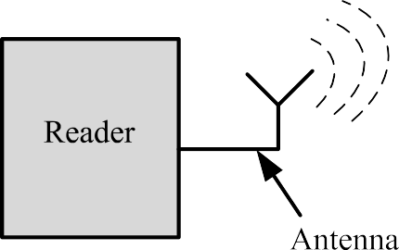

Figure 2.1: Main UHF RFID system components with single reader and back- scatter UHF tag

**Active tags** Active tags are the second commonly used type of tags. They have a fully autonomous power source [23,24]. These devices are more expensive than passive ones (starting from 10 €) because they incorporate circuits with a microprocessor and a memory to read, write, rewrite or erase data from an external device. However, there are several advantages of active tags compared to the passive ones. Among them; active tags support long reading distance, i.e. more than 100 meters. In addition, they also support immunity to the interference especially in harsh environment e.g. environments with excessive amounts of metals, such as shipping containers. Owing to their power supply property, they are easily connected with sensors, thus, monitoring the environment depending on the application e.g. food or drug shipments.

**Semi-passive tags** In semi-passive tags, batteries are used on board to power the controller or the chip and may contain additional devices such as sensors [25,26]. The signals, which are generated by the reader are only used to activate tags in coverage. Then, the tag’s reply is generated using the energy emitted from the internal batteries. Semi-passive tags can communicate over longer distance than the normal passive tags. Moreover, the circuitry activation of the semi-passive tags is faster than in passive tags.

## Readers

The RFID reader is the most important element in an RFID system [23]. It is responsible to access the tag information. The reader decodes the received data from the tags then sends this information to the middle-ware. The reader performance depends strongly on two factors: First, the decoder architecture. Second, the antenna design.

**Decoder architecture** Readers can be classified according to the type of tags as follow:

**Readers dealing with active tags** In active RFID systems, since active tags are able to initiate the communication between them, any active tag can act as a reader. However, when active tags act as a reader, they must be connected to a computer or a network (via a wired or wireless link) to send the received data from its network [22].

**Readers dealing with passive tags** They must meet the following key requirement: Their transmission power must be sufficient to feed the surrounding passive tags [13]. These tags obtain energy from the transmitted signal using back-scattering technique. Back-scattering technique is the reflection of the reader’s carrier wave where it modulates the signal which includes the tag’s data. Then, the reader detects the tag’s response, processes the signal and reads the information sent by the tag.

**Antennas** Antenna designs are strongly dependent on the operating frequency [27]. In case of low range applications, such as LF (125 kHz) or HF (13*.*56 MHz) range, antennas are embedded in the readers. However, in case of UHF applications, antennas have to be external. Moreover, polarization of the used antenna is one of the most critical issues. Antenna polarization affects directly the RFID system performance. In RFID systems, there are two types of antenna polarization:

**Linearly polarized antennas** Using these antennas, the electrical field component of the transmitted signal is propagated in a plane, and tags have

* 1. *FREQUENCY BANDS* 11

to be also orientated in the same direction of the transmitted signal [28]. For optimum receiving efficiency, this technique requires linearly polarized tags.

**Circularly polarized antennas** Using these antennas, the electromagnetic waves are transmitted in circularly polarized patterns. This type of polarization is used when the orientation of tags with respect to the reader cannot be controlled. Using circularly polarized antennas, a communication with both, linearly and circularly, tags can be established. However, circularly polarized antennas have a shorter reading range compared to the linearly polarized ones [29, 30].

## Middle-ware

In some applications, the tag identifier is used as an input for a database to get an information related to this object e.g. shipment orders, expiring date, etc. This kind of processing is done in a set of software tools called middle- ware. The EPCglobal standards [11] define specifications for the middle-ware of RFID systems. Meanwhile, RFID systems are still an evolving technology. Thus, RFID middle-ware should be flexible enough so that it could be adapted to the future changes with minimal efforts.

# Frequency Bands

The most important differentiation criteria for RFID systems are the operating frequency of the reader. Selecting the most adequate frequency is a function of the following properties:

* + - Technical properties of the application e.g. The RFID channel contains metals or not.
    - Cost of the system.
    - Behavior of the electromagnetic waves at these different frequencies.

First RFID systems started with Low Frequency (LF) band RFID systems [31]. After few years, the RFID systems have operated in High Frequency (HF)

Table 2.1: Frequency Bands for RFID Systems [32]

|  |  |  |
| --- | --- | --- |
| Frequency Band | Range | Common Frequencies |
| Low Frequency (LF) | 0*.*5 m | 125 kHz, 134*.*2 kHz |
| High Frequency (HF) | 1 *−* 3 m | 13*.*56 MHz |
| Ultra High Frequency (UHF) | 10 m | 866 MHz Europe  915 MHz USA |
| Microwave (*µ*W) | *>* 10 m | 2*.*45 GHz, 3*.*0 GHz |

band [32]. Using only these two band made a big limitation on the RFID applications. Thus, recent years, the number of RFID systems operating in the Ultra High Frequency (UHF) range have increased because of the dramatic decrease in its component’s price [33]. Thus, it is expected to see the RFID microwave band more available and affordable in the market. The availability of all bands with affordable costs will give the RFID users more facilities to take easier decision in which band they need to build up their applications.

Table 2.1 presents the most common frequencies for each band as well as the maximum allowed distance for each band. It is necessary to note that Table 2.1 does not present the only possible operating frequencies. It presents only the most commonly used frequencies in each band. Thus, it is possible to find systems operating at different frequencies within each frequency band. This thesis focused upon the UHF frequency band, because it is suitable for the passive dense RFID applications.

# RFID Communication Standards

There are different standards of the communication between the RFID reader and the corresponding tags. Although the EPCglobal C1G2 standard is the most extended and adopted for passive dense RFID networks, yet, there are further other standards. Table 2.2 shows the most common RFID standards with a short description for each one. This thesis discusses the Generation 2, Class 1 standard, because it is the most suitable standard for dense RFID network, as the cost of the system is ideal for such applications.

Table 2.2: RFID standards classification [11]

|  |  |
| --- | --- |
| Standards Classification | Description |
| Generation 1, Class 0 | Read only passive tags  Unique EPC programmed in the factory |
| Generation 1, Class 0+ | Identical to the normal Generation 1, Class 0 tags Tags can be programmed by users |
| Generation 1, Class 1 | Similar to Generation 1, Class 0 or 0+ tags Identified by readers from different companies |
| Generation 2, Class 1 | Faster data rates then Generation 1 tags Rewritable memories |
| Generation 2, Class 2 | Similar to Generation 2, Class 1 tags |
| More noise immunity |
| Generation 2, Class 3 | Semi-passive or battery assisted tags |
| Generation 2, Class 4 | Active tags |
| Generation 2, Class 5 | Active tags  Capability to power on other tags |

# Collision Problems

In RFID systems, both readers and tags communicate using the same frequency. Thus, simultaneous transmission could happen that leads to collisions. Collisions destroy the identification number EPC of the tag and may also interfere control commands of the readers. Thereby, the collision problem is the main source of delays in the identification process. There are two types of collisions: reader collisions and tag collisions. The following sections describe in detail both types and how each of them affects the performance of the system.

## Readers Collisions

There are two main types of readers collisions or interference in RFID systems: multiple readers to tag collision and reader to reader collision.

**Multiple Readers to Tag Collisions:** Multiple readers-to-tag collisions occurs when one tag is simultaneously located in an overlapped area between two neighbor reading areas [34, 35], and both readers communicate simultaneously with the shared tag as shown in Figure 2.2. In this situation, the tag will not be able to determine such communication, due to the interference between the two readers commands.

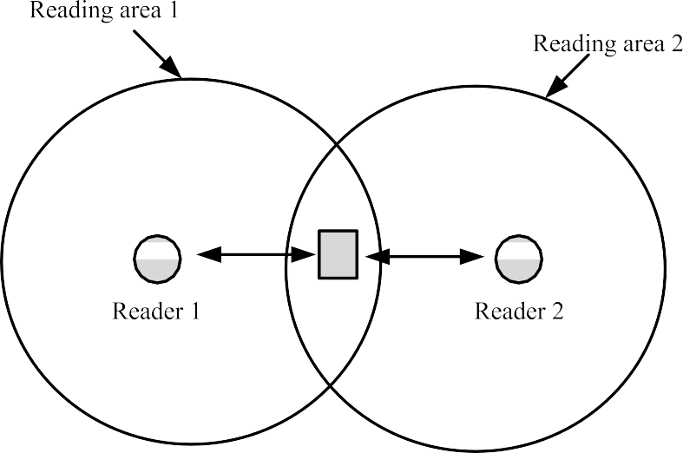

Figure 2.2: Multiple readers to a single tag collision

Therefore, the tag will not respond to any readers. Finally, this slot would be an empty one leading to losses in the total identification time.

**Reader to Reader Collisions:** Reader-to-reader collisions, or interference, occurs when the signal generated by a reader acts as a jamming signal for a neighbor reader as shown in figure 2.3. This signal might prevent the second reader from communicating with its tags in its reading area [36, 37]. Such interference can occur even if there is no overlapping area between the reading areas. This interference affects the total identification time of the interfered system.

## Tag Collisions

This type of collision is the most common type of collision in dense RFID systems [38–41]. In such systems, we have a single RFID reader and multiple tags as shown in Figure 2.4. The main objective is to identify all tags in the reading area in the minimum possible time. However, in dense networks, the number of tag collisions increases, which decreases the reading efficiency, and hence increases the reading time. Different research groups are currently associated with how efficiently develop an anti-collision protocol for such systems.

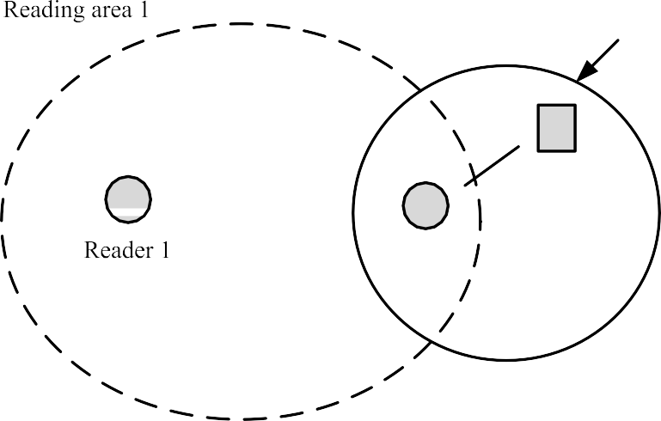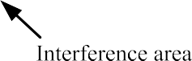

Figure 2.3: Multiple readers interference

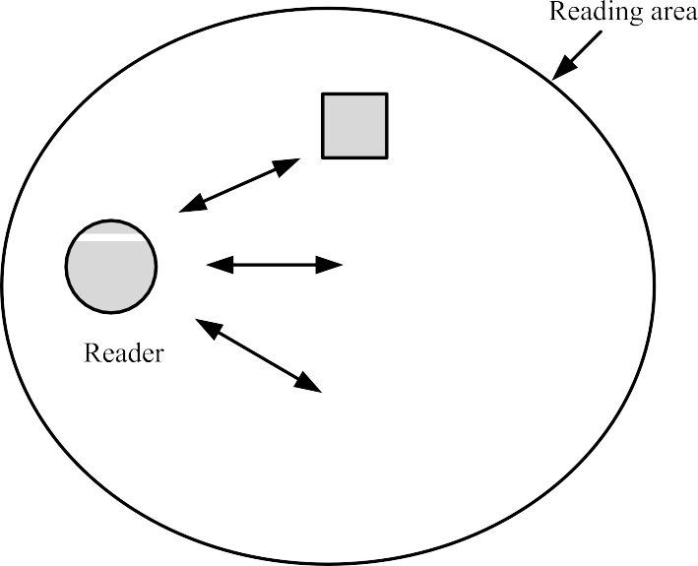

Figure 2.4: Multiple tags to a single reader collision

Table 2.3: RFID standards classification [11]

|  |  |
| --- | --- |
| Standards Classification | Description |
| Generation 1, Class 0 | Read only passive tags  Unique EPC programmed in the factory |
| Generation 1, Class 0+ | Identical to the normal Generation 1, Class 0 tags Tags can be programmed by users |
| Generation 1, Class 1 | Similar to Generation 1, Class 0 or 0+ tags Identified by readers from different companies |
| Generation 2, Class 1 | Faster data rates then Generation 1 tags Rewritable memories |
| Generation 2, Class 2 | Similar to Generation 2, Class 1 tags |
| More noise immunity |
| Generation 2, Class 3 | Semi-passive or battery assisted tags |
| Generation 2, Class 4 | Active tags |
| Generation 2, Class 5 | Active tags  Capability to power on other tags |

Anti-collision protocols can be classified into two main types: Physical layer protocols and MAC layers protocols. In this thesis, I am focusing on the applications which include only a single RFID reader and dense RFID tag populations. The main motivation of this thesis is to minimize the total identification time for a dense and passive RFID networks. Therefore there are different proposals to solve the tag collision problem by enhancing the existing anti-collision protocols taking into consideration the physical layer parameters. Moreover, the applications of the dense RFID networks are following the EPC- global C1 G2 standards [11]. Thus, the proposed improvements in this thesis are done only on the reader side. Finally, chapter 6 will propose slight modifications in the standard to have further improvements and, at last, compare the results against each other.